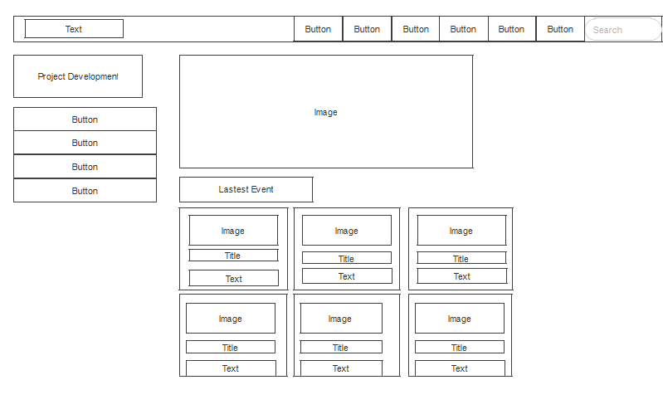

Figure 1

Figure 1 show the image of company project for customer view. There is also some button to let customer register and view the about us and contact us of the company. There is also a FAQ button let customer to go in the page to ask question and a button to booking. There is also a search boxes to let customer search the detail that the want. Figure 1 also ha 4 button that let customer to view the project of the company. Figure 1 also show the latest event of the company.

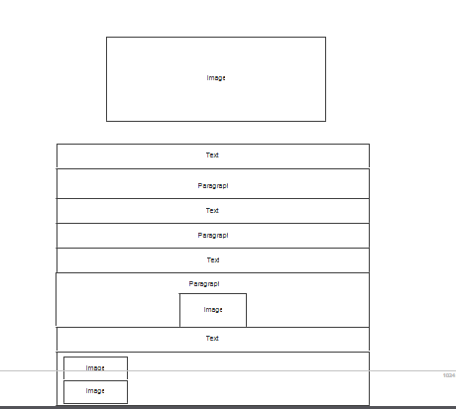

Figure 2

This is the story board for project development. Project storyboard include 4 projects. This is one of the project development. Others three are similar to this page. This page provides the specification of the project.

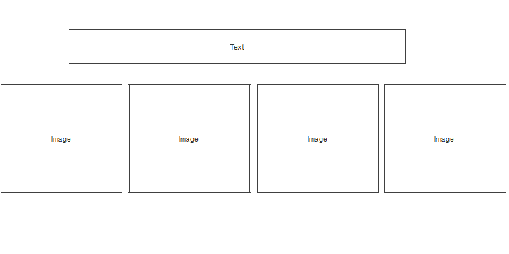

Figure 3

This page is the storyboard of the company latest event. Event storyboard include 6 events. This is one of the event. Others 5 is similar to this page. This page provides the image of the event.

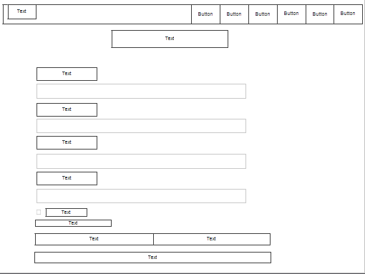

Figure 4

This page is the storyboard of register page. There is some textbook that let customer to fill in their detail and there is some button that let customer to cancel the register, clear the detail or confirm to process.

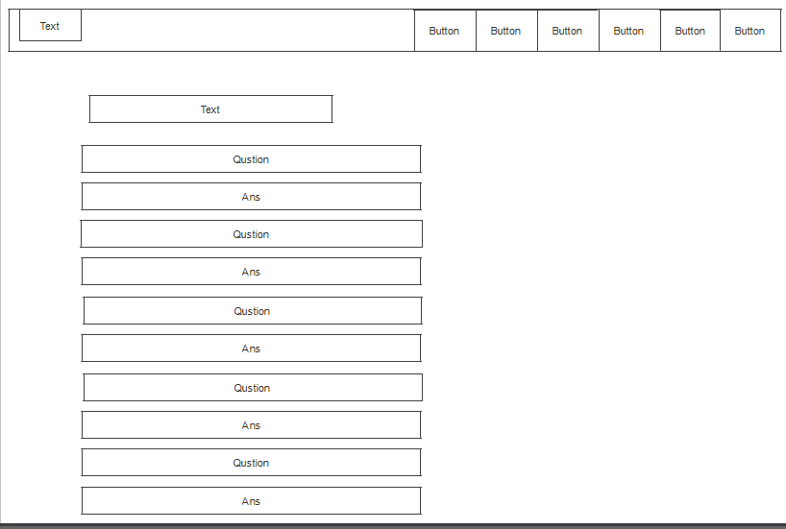

Figure 5

This page is the storyboard of the FAQ pages. This page shows the question that customer always want to ask, and this page also provide the answer of the question.

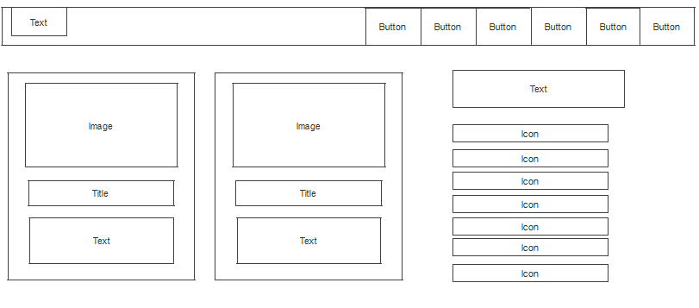

Figure 6

This page is the storyboard of contact us page. This page shows the location and the detail of the company.

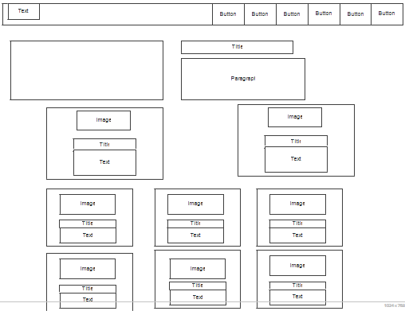

Figure 7the

This page is the storyboard of about us page. This page shows the introduce of the company and the vision and mission of the company. At the down of the page also show the management team of the company.

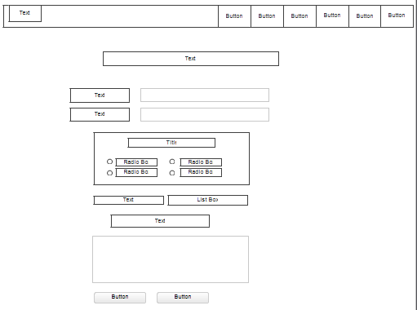

Figure 8

This page is the storyboard of the booking page. This page has the textbox let the customer to insert their detail and radio box to let the customer to choose the project that the want to book. There is also a list box that let customer to insert the number of person and there is a textbox that let customer to type in some comment to the company. There is also two buttons to let the customer to submit the comment or clear the comment.

Website Development Method

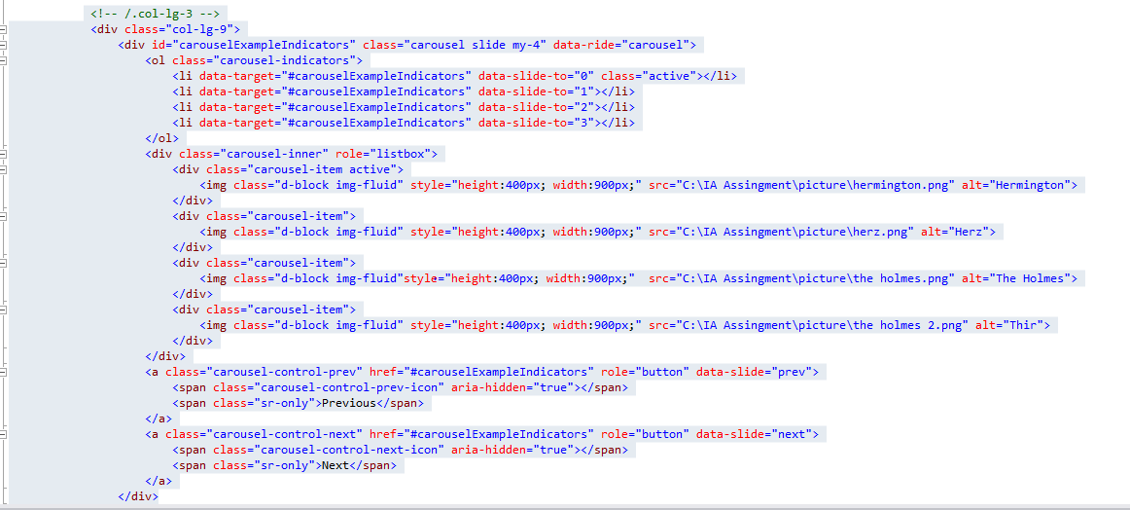

Figure 9

This HTML Code is to make the slide show in the homepage and other pages as well.

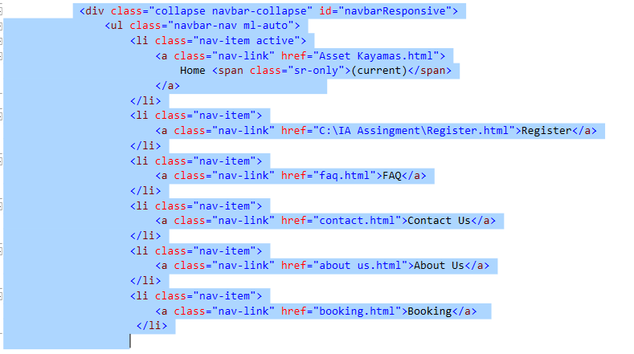

Figure 10

This HTML Code is to make the Navigation bar which implied in most of the pages.

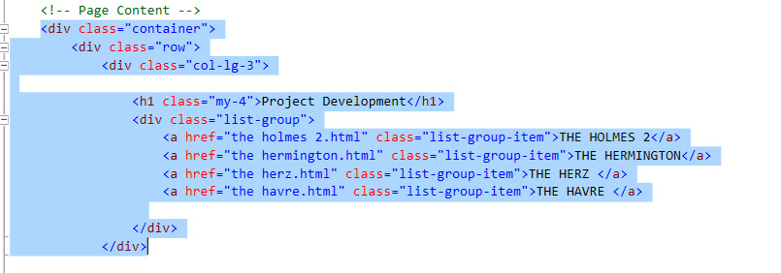

Figure 11

This HTML Code is to make the list which located at the left side of the home page.

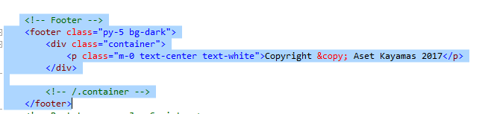

Figure 12

This HTML Code is to make the footer in the bottom of the page.

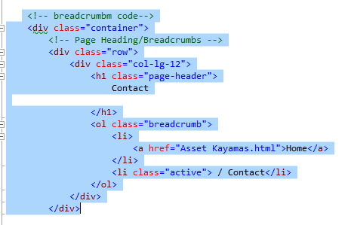

Figure 13

This HTML Code is make the breadcrumb container in the head of the page of contact page and so on.

Navigation Structure

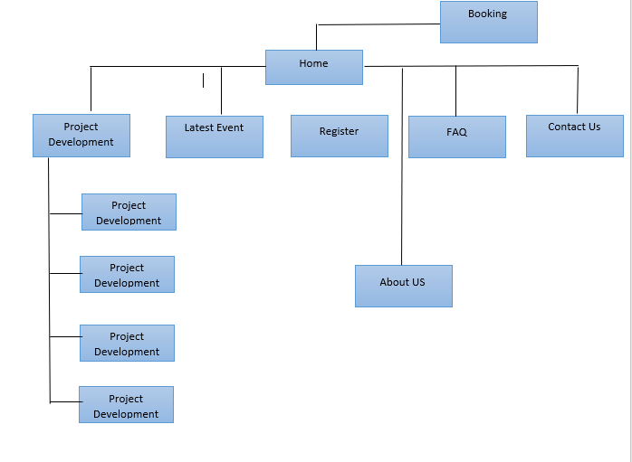

Figure 14

**Conclusion**

This is our first webpage we ever created using HTML, CSS and Java. Thanks to lecture for guiding us forward. We believe the website that we made can be applied elsewhere and can provide anyone to know more about the project of Aset Kayamas company. In short, Aset Kayamas webpage is the client's corporate system. Based on this system, we learned how to create a software system to bring more convenience to our customers.

The aim of our project is let the customer know more about the information and project of the Aset Kayamas company. Our webpage also let the customer to search the information that they need from Aset Kayamas. Our webpage provides the detail of the project of the company to anyone who come to our webpage. Therefore, the customer also can search the detail of all project of Aset Kayamas from our webpage. The customer also can bookings the project of Aset Kayamas through our webpage.

The challenge of this system is to require Internet access and exploration booking systems. Customers require a reliable internet connection to make a reservation, and when you are in a bad signal area, the customer will not be able to book facility services because the booking may fail and wastage of the customer's time. Another challenge is that the interface cannot attract customers. The first impression is very important because it determines the customer's loyalty and passion for the future. The next challenge is the need to prepare for the influx of new customers, as many people prefer to book online via mobile devices and computers. This can be a challenge when the system is running a small operation that does not have enough source.